ADDENDUM TO CONTRACT FOR LEGAL SERVICES, FLAT OR FIXED FEES CLIENT

___________________________and Joseph La Costa entered into a contract for legal services dated ___________________________-for attorney to perform the following legal services: related to Bankruptcy is charging, and CLIENT(S) agrees to pay off their flat fixed fee in the amount of $2,000.00 plus Filing fees for the services described above, or will make interim payments from time to time .

CLIENT(S) acknowledges California Rules of Court 1.15 (b) which provides a fee paid in advance for legal services may be deposited in the attorney’s operating account and not the attorneys trust account as otherwise required by rule 1.15 (a) if:

- Attorney discloses to CLIENT(S) in writing: 1) the CLIENT(S) has the right under rule, 1.15 (a) a to require the flat fee to be deposited in an identify trust account until the fee is earned, and 2) that the CLIENT(S) is entitled to a refund of any amount of the fee that has not been around in the event of representation is terminated early services, for which the fee has been paid or not completed and
- If the flat fees exceeds $1,000. CLIENT(S)s agreement with attorney deposit of the fee in attorney‘s operating account and disclosures required by rule 1.15 or set forth in writing by the CLIENT(S) Excepting payments, designated, identified, or otherwise agreed to be for costs, which attorney will deposit in the Attorney Trust Account. CLIENT(S) authorizes attorney to deposit all sums paid to Attorney by CLIENT(S) as part of his fees into the Attorneys Operating Account. Attorney will seek CLIENT(S) written authorization for deposit into his operating account each and every payment CLIENT(S) makes payments of fees as described herein by signing here to CLIENT(S) authorizes attorney to deposit into the operating account, the entire portion of the flat fee paid this date by CLIENT(S)

DATED:___________________

_______________________________

________________________________

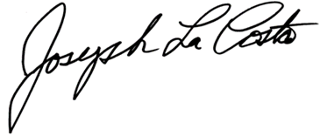

______________________________
Joseph La Costa, Attorney-At-Law.

